GULISTAN & TURGUT OZAL EDUCATIONAL INSTITUTIONS
INFORMATICS LESSON PLAN

DATE :
DURATION : | 40 minutes
GRADE LEVEL: | 10th Class
SUBJECT : | Using Styles and Page Break 1
OBJECTIVES : | To learn about styles and page breaks

LESSON PLAN
Key words:
Materials used: | Microsoft Excel 2003 Book, Computer
Warm-up questions:

Introduction and explanation of the lesson;
USING STYLE
A Style is a collection of formats such as font size, color, patterns, and alignment that you can predefine and save as a group. Once you have defined and saved a style, you can apply all of the formatting elements at once.
A Style can contain any (or all) of the following formatting attributes:
 Number
 Font (type, size, and color)
 Borders
 Alignment
 Pattern
 Protection (locked and hidden)

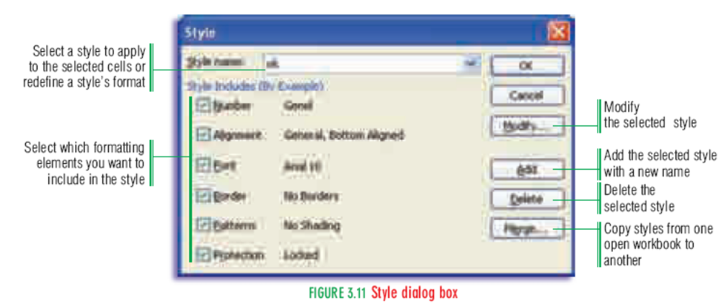

CONCLUSION:

HOMEWORK:

Teacher Director

